Excel Add-In to Manipulate Points on Charts (MPOC)

Contents

2 Introduction 1

3 Installation 1

4 How to Use 3

5 MPOC Dialog 5

5.1 Series 5

5.2 Point 5

5.3 Value Controls 6

5.3.1 Handling Formulas – Goal Seek 6

6 Known Limitations 7

# Introduction

The “Excel Add-In for Manipulating Points on Charts” (MPOC) Add-In is an Excel solution that allows direct manipulation of data points on an Excel Chart through a dialog.

This Add-In is meant to provide the same basic functionality as “Graphical Goal Seek” - a feature that was present in Excel 2003. In Excel 2003, users could directly manipulate data points on the chart by dragging them. However, this feature is no longer available in Excel 2007.

Some of the benefits of this Add-In are that it supports all chart types. Data points can be more quickly selected and changed through the dialog via the keyboard.

IMPORTANT: **Please back-up your file before using the MPOC Add-In**. The undo functionality in Excel will NOT work since this Add-In is written entirely using VBA. Also, this is a sample Add-In, so please exercise caution before using it on important data.

# Installation

1. Save Add-In file (Manipulate_Points_on_Charts_*.xlam) to the “AddIns” location on your computer. Typically, this is:

“C:\Users\<user name>\AppData\Roaming\Microsoft\AddIns\”

*If the AddIns folder does not exist, create one.

1. Start Excel 2007
2. Click on the Office Button in the top-left corner

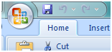

1. Click on “Excel options” Button in the menu



1. In the “Excel Options” dialog

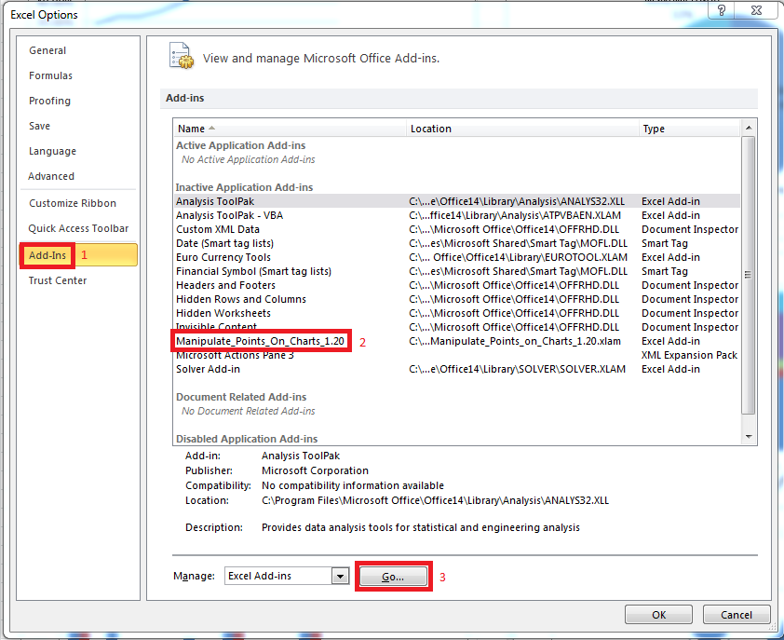

* 1. Select “Add-Ins” in the left column
  2. Clink the “go” button to Manage Excel Add-Ins

1. Check the “Excel Add-in for Manipulating Points on Charts” Add-In and click OK.
   1. If not listed, click on the Browse button and browse to the add-in in the location mentioned in Step 1.

NOTE: Uncheck any earlier versions of the MPOC Add-In that you may have previously installed.

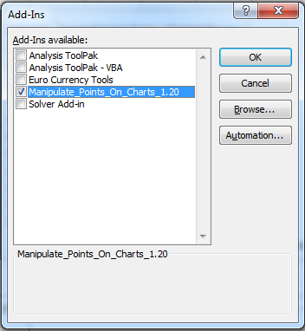

1. Add-In is now enabled and available every time you boot Excel.
2. A “Manipulate Points“ button will now appear whenever a chart object is selected under the “Chart Tools -> Layout” Tab of the Ribbon.

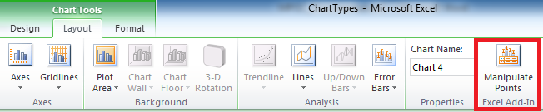

9. Click this Button to Launch the MPOC Dialog.

# How to Use

1. Start Excel
2. Insert a simple chart (for this example we will be using a simple column chart)
   1. Enter some data in Excel as follows:

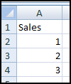

* 1. Select the cells A1:A4
  2. Insert a simple 2-D column chart
     1. Go to Insert Tab of the Ribbon
     2. In the Charts Group: click on Column -> Clustered Column



1. Select the newly inserted chart and click on the Chart Tools “Layout” tab
2. A “Manipulate Points“ button will now appear whenever a chart object is selected under the “Chart Tools -> Layout” Tab of the Ribbon.



1. Click this Button to Launch the MPOC Dialog.

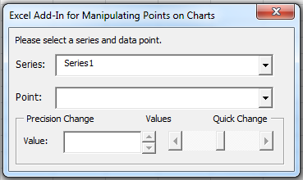

1. Choose the Series in the dropdown. Let us choose “Sales”. (OR just click on the series on the chart with your mouse)
2. Choose a Point. Let us choose “Point 2”. The value of this point will be automatically shown in the Value Textbox. (OR just click on the point within the series on your chart).
3. Use the Spin-Button or Textbox or Sliders to change the values of the chart.
   1. The new value will be written onto the worksheet cell that corresponds to this point on the chart.
   2. The chart will be updated to show this new value instantly.

# MPOC Dialog

The MPOC dialog is a modeless dialog. This allows you to select data points on the chart through the dropdown controls or by clicking on the chart directly with your mouse while the dialog is still open.

The MPOC dialog has the following controls:

## Series

This dropdown is pre-populated with all the series on the active chart. Use the drop-down control to select a different series on the chart.

When there are more than 50 series on the chart, the drop-down control is replaced by a Spin-Button control and a Text Box. You can move to a different series by using the Spin-Box control or by typing the name of the series in the text box. In such cases, mouse-clicks might be a more efficient way of selecting a different series on the chart.

## Point

This dropdown is pre-populated with all the data points in the selected series. Use the drop-down control to select different data points in the selected series.

When there are more than 50 data points in a series, the drop-down control is replaced by a Spin-Button control and a Text Box. You can move to a different point by using the Spin-Box control or by typing the index of the point in the text box. In such cases, mouse-clicks might be a more efficient way of selecting a different point in the series.

## Value Controls

Value controls are used to directly manipulate the value of the cell corresponding to the selected point on the chart. We dynamically add additional value controls depending on the type of the chart. For example, x-y scatter charts have two value controls and bubble charts have three value controls.

The Spin-Buttons for a value controls dynamically change based on the range of the chart (minor unit of the axis). Each click of the spin button will change the value by 10% of the minor unit value of the axis. If this value is less than 1, each click will change the value by 1.

The Scroll bar provides a quick way of changing the points on your chart. Each type of value control is designed for different level of precision. We recommend using scroll bars for making big changes and using the spin buttons for greater control. If you know the value you need, type the value directly in the text box.

### Handling Formulas – Goal Seek

Value controls will not overwrite formulae in a cell. In such cases, we will pass the control to the Goal-Seek Add-In. When using scrollbars or spin-buttons, we automatically delay bringing up the dialog so that the user action is not interrupted by the Goal-Seek dialog. This allows you to settle on the value you want before the Goal-Seek dialog shows up.

**NOTE**: When a cell contains a formula, the chart won’t update in real time to reflect the changes in the dialog. This is to avoid cases where such a value may not be possible due to the limitations of the formula being used.

For Example:

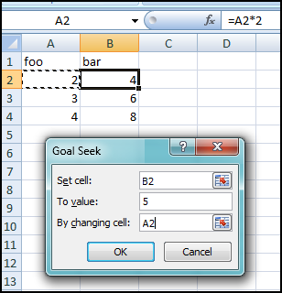 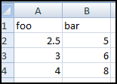

1. We have a worksheet where cell B2 contains a formula “=A2*2”
2. Trying to change the value of the point corresponding to cell B2 will bring up the Goal-Seek dialog. In this example, we want B2 to have a value of 5.
3. You can enter the cell whose value you want to change to affect the value in B2. In our example, we choose cell A2.
4. Goal seek affects the change by changing the value of A2 to be 2.5.

# Dialog Appearance

The Add-In allows users control over the appearance of the dialog using the registry keys. We encourage you to try out both forms of the dialog and see which type you like the best. For our example, we will use an X-Y Scatter chart with the “Quantity” plotted on the x-axis and the “Cost” Plotted on the Y-axis.

## Compact Form

By default, the dialog appears in the compact form. You can also use the provided registry file “MPOC_Compact_Form.reg” to get the dialog to the compact state.

In this state, all the slider controls appear in the horizontal direction.

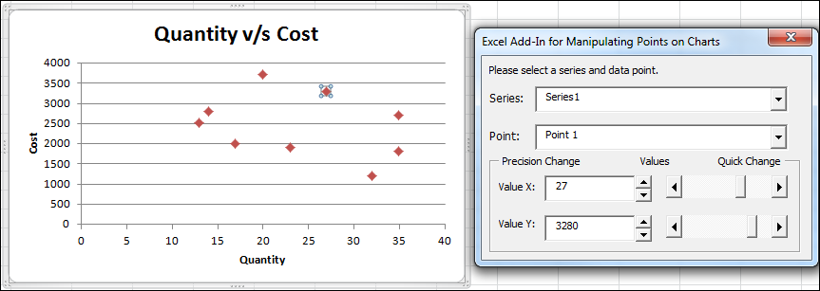

The advantage of this design is that the compact form allows greater room to click on different points on your chart. However, it may seem a little strange to move “Cost” points up/down using a horizontal slider.

## Expanded Form

You can also use the provided registry file “MPOC_Expanded_Form.reg” to get the dialog to the expanded state.

In this state, all the slider controls appear in direction that the points are supposed to move.

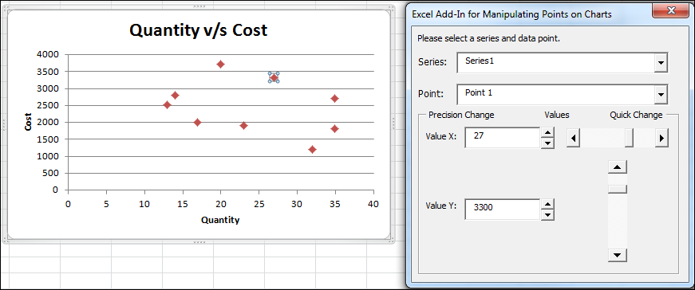

The advantage of this design is that moving the points using sliders is more intuitive – we can change “Quantity” using a horizontal slider and “Cost” using a vertical slider. However, the larger form size might come in the way of selecting different points on the chart.

# Known Limitations

The “Excel Add-In for Manipulating Points on Charts” does not support the following scenarios:

1. This Add-In does not work for Cross Workbook scenarios. The controls of the dialog will be disabled in such cases.
2. This Add-In does not work with Pivot Charts because the values in the Pivot Table cannot be overwritten.
3. This Add-In may not work with series names that have strange characters such as carriage returns. This is due to the limitations of the form controls used by this Add-In.
4. This Add-In does not support UNDO functionality. The undo functionality in Excel will NOT work since this Add-In is written entirely using VBA. Also, this is a sample Add-In, so please exercise caution before using it on important data.